**Table of Contents**

1.0 Introduction 2

2.0 Business Rules 3

3.0 Entity Relationship Diagram 5

4.0 Database Diagram 6

5.0 SQL Statements 7

5.1 Data Definition Language (DDL) 7

5.2 Data Manipulation Language (DML) 17

5.2.1 Question 2 (b) (i) 17

5.2.2 Question 2 (b) (ii) 18

5.2.3 Question 2 (b) (iii) 19

5.2.4 Question 2 (b) (iv) 20

5.2.5 Question 2 (b) (v) 21

5.2.6 Question 2 (b) (vi) 21

5.2.7 Question 2 (b) (vii) 22

5.2.8 Question 2 (b) (viii) 22

5.2.9 Question 2 (b) (ix) 23

5.2.10 Question 2 (b) (x) 23

# 1.0 Introduction

This report aims to document the design and implementation of a database system for an electronic bookstore called E-Bookstore. The report consists of an introduction where advantages of databases and the Database Management System (DBMS), in the context of the electronic bookstore are discussed, followed by the emphasizing of the various business rules that govern the said database, the display of the Entity Relationship Diagram (Crow’s Foot Notation) and the Database Diagram, and subsequently, the SQL statements in terms of Data Definition Language (DDL) and Data Manipulation Language (DML).

In the context of the E-Bookstore, having implement a database would greatly increase the efficiency of the bookstore’s ability to manage and use data. Not only is the E-Bookstore able to store large amounts of data ranging from the most basics of information such as the particulars of its members all the way to the entire E-Bookstore’s extensive inventory and supply-chain record, both in a systematic and organized manner, a database also allows for the process of retrieving data to be done in a much seamless and streamlined manner. Besides storage and the retrieval of data, setting up a database management system for the E-Bookstore would also enable for better management of the bookstore’s inventories, more importantly so since the bookstore is an online business model. In addition to that, implementation of a database management system ensures that data consistency within the bookstore’s ecosystem is maintained at the highest level, on grounds that there are various data validation rules and constraints which were put in place to govern the said database. At the same time, because a database allows for the sharing of information across all levels of stakeholders of the organization, thereby making it unnecessary to have duplicating data, data redundancy within the E-Bookstore is hence said to be greatly reduced as a result of the implementation of such a database management system.

Improved integration of the E-Bookstore’s data would also be possible as the E-Bookstore’s database could then be used to integrate with other systems and platforms connected to the bookstore, such as its delivery partners or its supply chain partners. Informative business insights, future prospect of the E-Bookstore’s business model and a more personalized experience for its members would then all be beneficial by-products of such improvement in its data integration. Lastly, in the event of a system failure within the E-Bookstore, data management system is able to ensure that no data would be lost in such events because data has already been backed up into the system, essentially allowing for the recovery and restoration of the E-Bookstore’s data. In short, comparing traditional file-based systems with the database management system, the latter provides more benefits over the former specifically in terms of data storage, data retrieval, improved inventory management for the E-Bookstore, data consistency, better data sharing, reduced data redundancy, improved data integration across various systems and platforms, and also improved backup and data recovery mechanisms.

# 2.0 Business Rules

Below is a list of the business rules that govern the E-Bookstore’s database system:

1. One MEMBER can only have one SHOPPINGCART. At the same time, one SHOPPINGCART must belong to one MEMBER only. Hence, there is only one *CartID* per member.
2. Each MEMBER will only have one *MemberID* and the *MemberID* would still remain the same even after the renewal of membership upon expiry.
3. One MEMBER can only give one FEEDBACK per book. FEEDBACK includes a rating from 1 to 10 (1 = Terrible; 10 = Masterpiece) and a short comment which is optional. Note that FEEDBACK cannot be changed once it has been made.
4. One FEEDBACK can only be given to one BOOK but one BOOK could have many FEEDBACKs.
5. One PUBLISHER can publish many BOOKs but each BOOK must belong to only one PUBLISHER.
6. *Price* in the BOOK table represents the individual price of a particular book.
7. One SHOPPINGCART can contain many BOOKs. At the same time, one BOOK can be added to many SHOPPINGCARTs.
8. *Quantity* in CARTDETAILS refers to the total quantity of BOOKs in the SHOPPINGCART.
9. ORDERTABLE represents the order placed by each member.
10. The *PaymentMethod* in ORDERTABLE refers to the total amount payable for a single order.
11. One BOOK can belong to many ORDERTABLE. At the same time, one ORDERTABLE can contain many BOOKs.
12. One MEMBER can have many ORDERTABLE but one ORDERTABLE must belong to one MEMBER only.
13. *TotalQuantity* in ORDERDETAILS refers to the total quantity of books placed within a single order.
14. There is a distinction between SHOPPINGCART and ORDERTABLE because books placed in the SHOPPINGCART need not be purchased but books placed in the ORDERTABLE is definitely going to be purchased.
15. One ORDERTABLE can only belong to one SHIPPING. At the same time, one SHIPPING must belong to one ORDERTABLE only. Hence, there must be one unique *ShipmentID* for each order placed.
16. The *Address* in MEMBER need not be the same as the *Address* in *SHIPPING.* This is because members could decide to send their shipments to another address other than the one registered with the E-Bookstore.
17. The *ExpectedDate* in SHIPPING must be within 7 working days after an order (represented by ORDERTABLE) has been placed. This means that the difference between the *Date* in ORDERTABLE and the *ExpectedDate* in SHIPPING must not exceed 7 working days.
18. One CATEGORY can have many BOOKs but one BOOK can only belong to one CATEGORY.

# 3.0 Entity Relationship Diagram

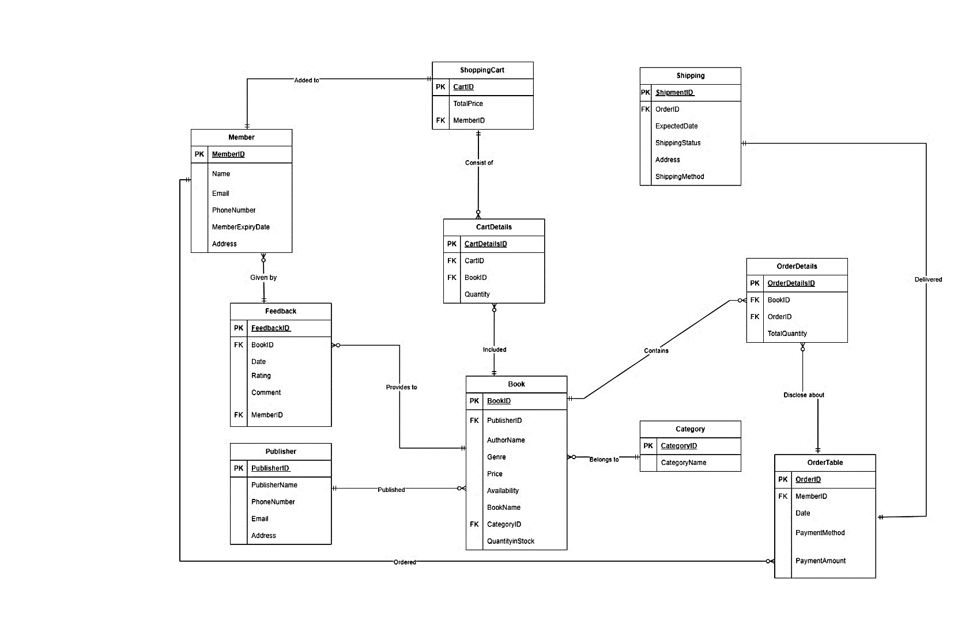

# 4.0 Database Diagram

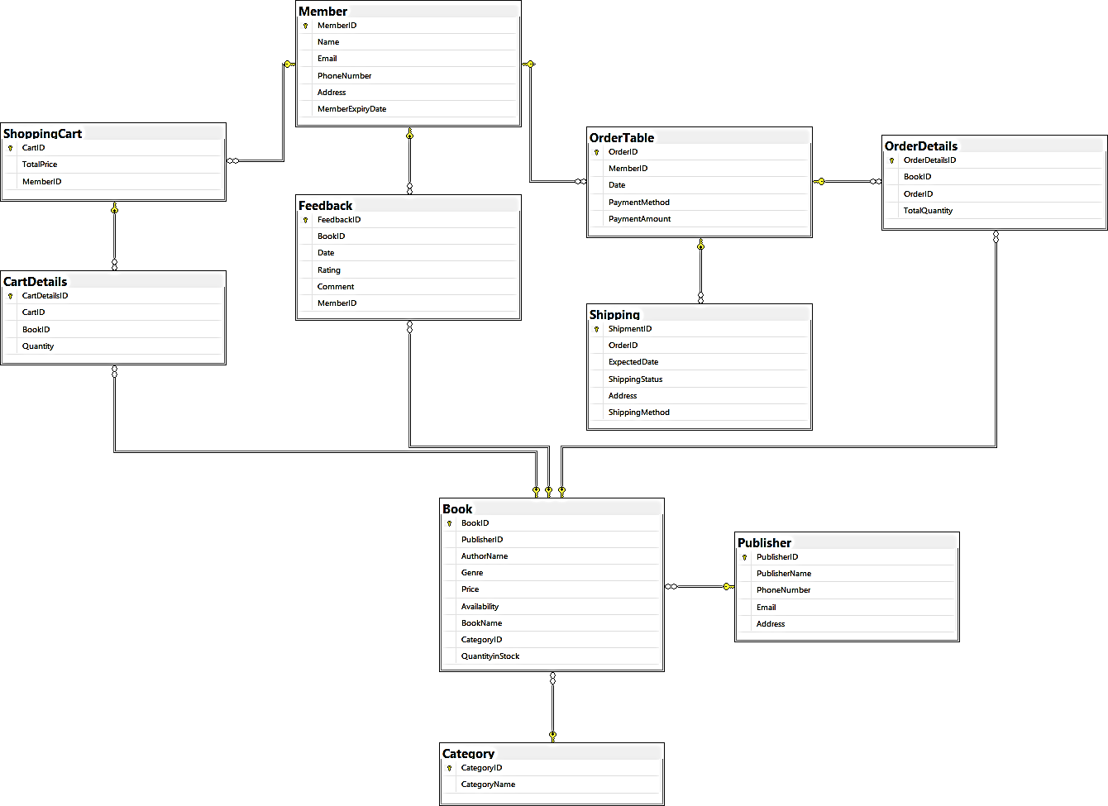

# 5.0 SQL Statements

## 5.1 Data Definition Language (DDL)



*Input for Member Table:*

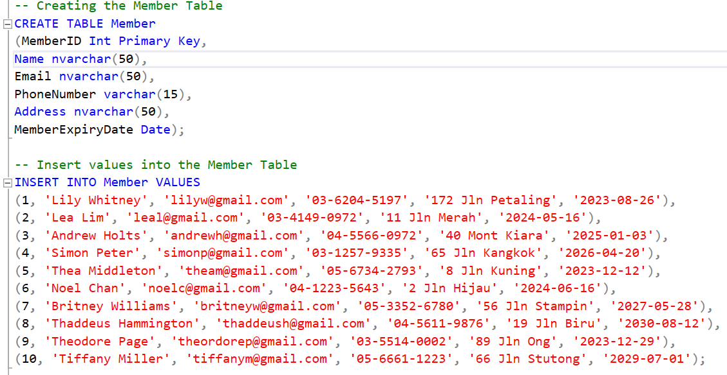

*Output for Member Table:*

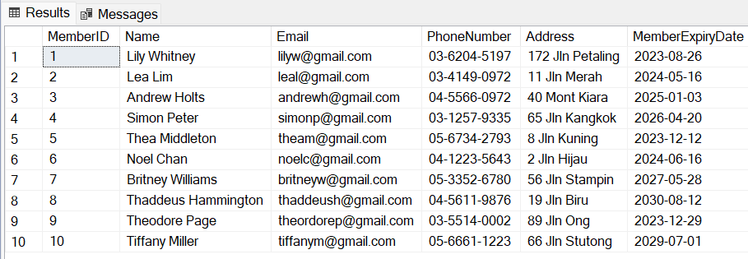

*Input for ShoppingCart Table:*

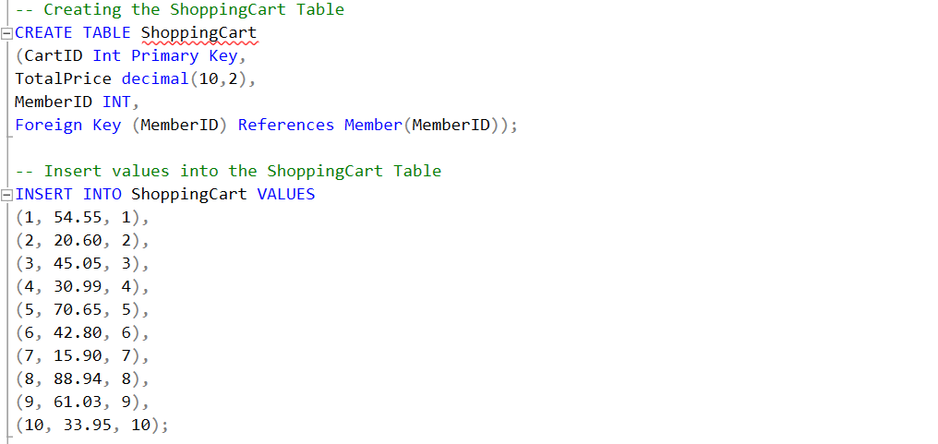

*Output for ShoppingCart Table:*

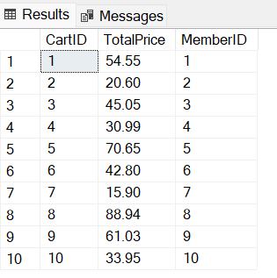

*Input for Publisher Table:*

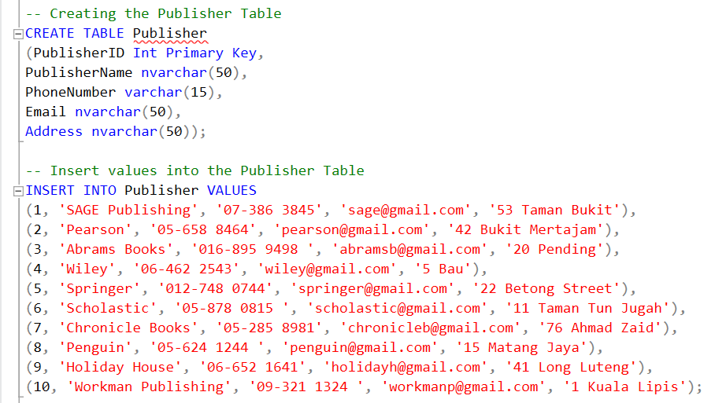

*Output for Publisher Table:*

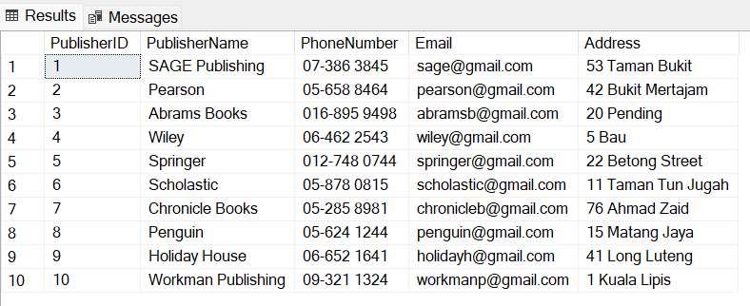

*Input for Category Table:*

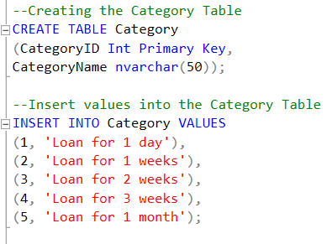

*Output for Category Table:*

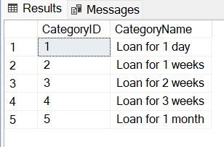

*Input for Book Table:*

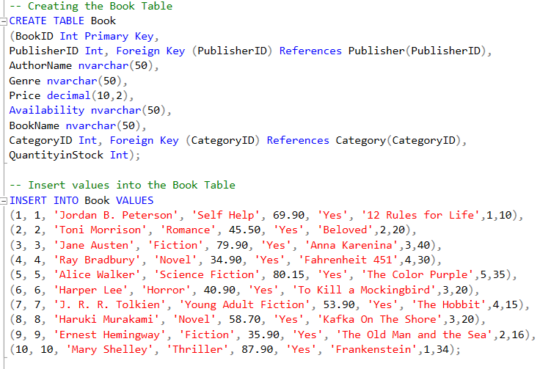

*Output for Book Table:*

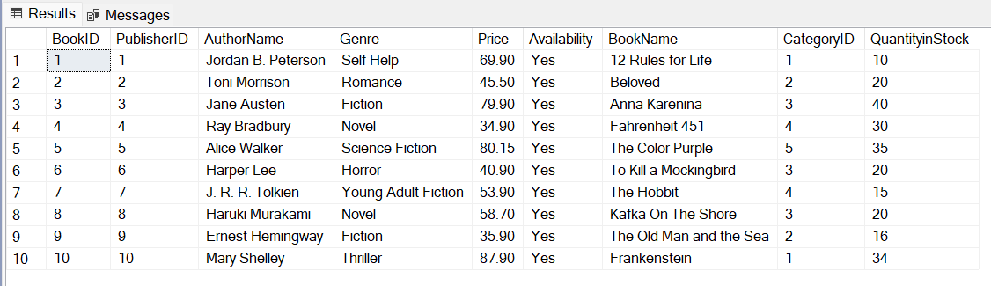

*Input for Feedback Table:*

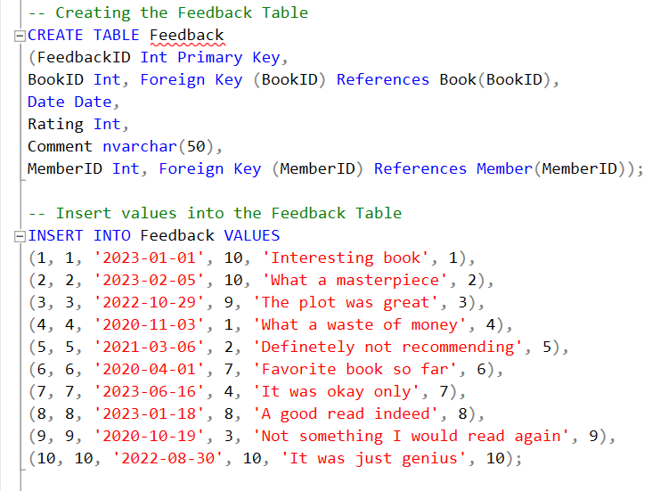

*Output for Feedback Table:*

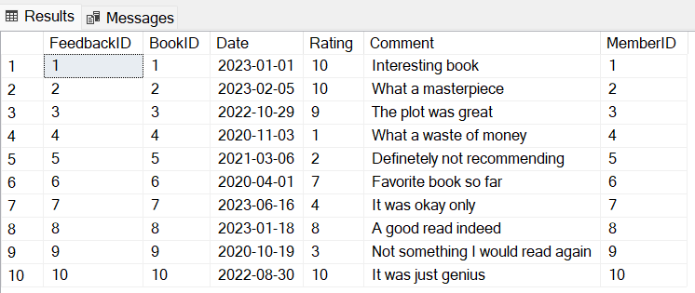

*Input for CartDetails Table:*

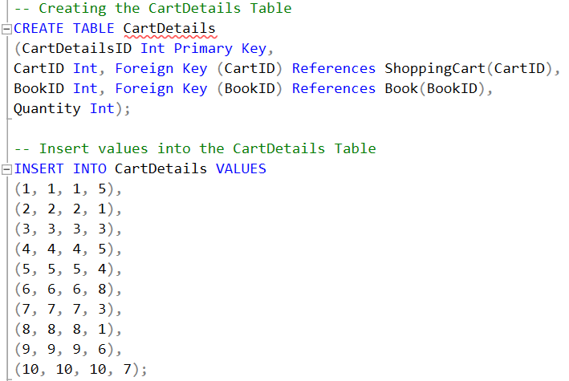

*Output for CartDetails Table:*

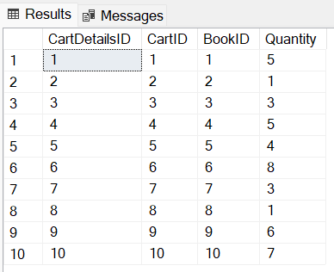

*Input for OrderTable Table:*

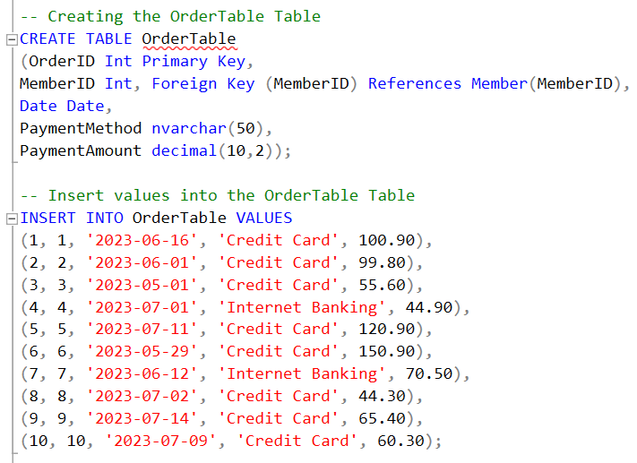

*Output for OrderTable Table:*

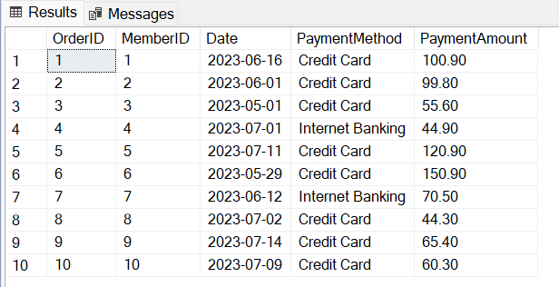

*Input for OrderDetails Table:*

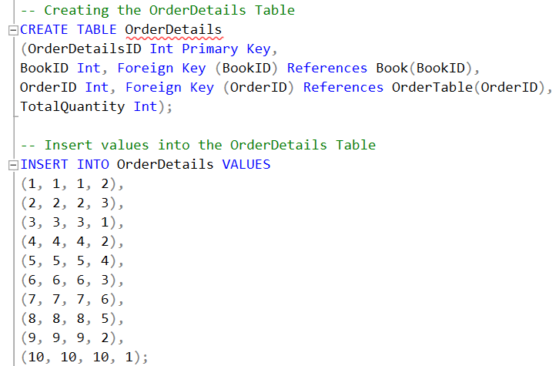

*Output for OrderDetails Table:*

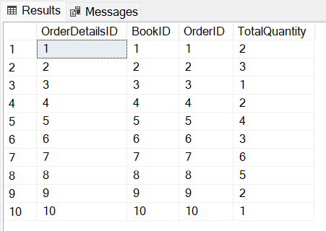

*Input for Shipping Table:*

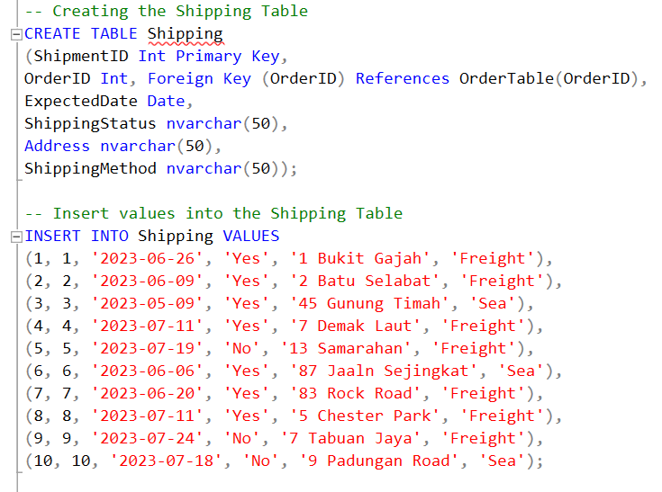

*Output for Shipping Table:*

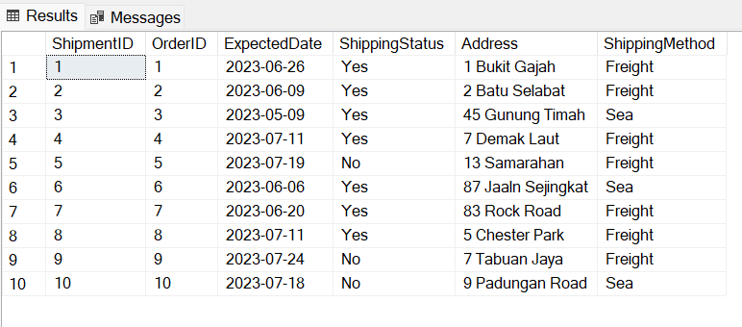

## 5.2 Data Manipulation Language (DML)

### 5.2.1 Question 2 (b) (i)

*Input:*

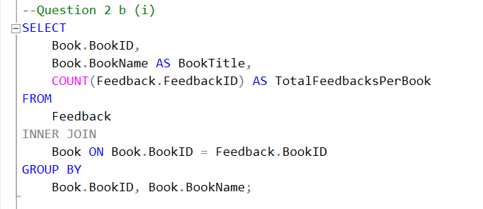

*Output:*

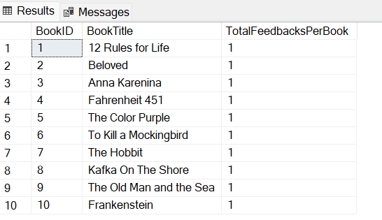

### 5.2.2 Question 2 (b) (ii)

*Input:*

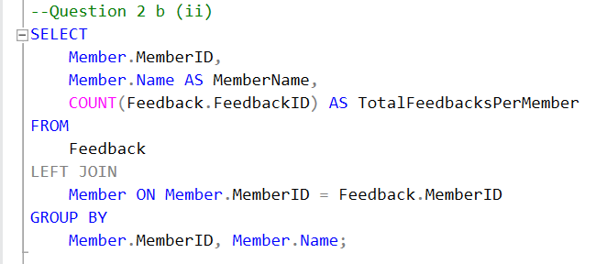

*Output:*

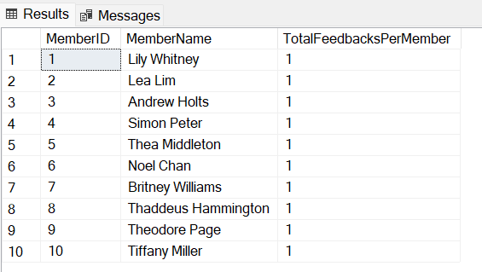

### 5.2.3 Question 2 (b) (iii)

*Input:*

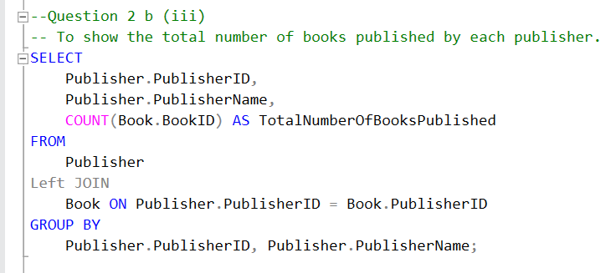

*Output:*

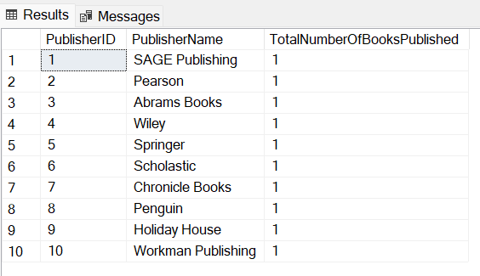

### 5.2.4 Question 2 (b) (iv)

*Input:*

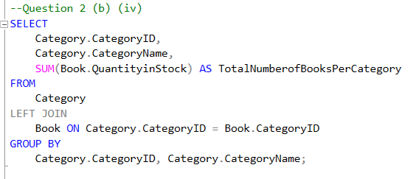

*Output:*

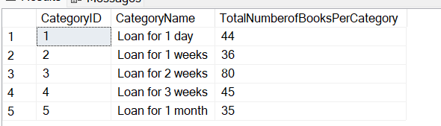

### 5.2.5 Question 2 (b) (v)

*Input:*

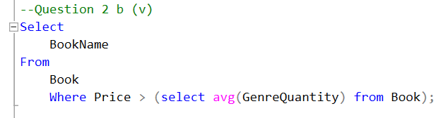

*Output:*

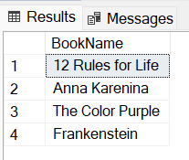

### 5.2.6 Question 2 (b) (vi)

*Input:*

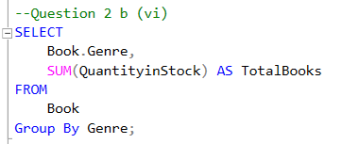

*Output:*

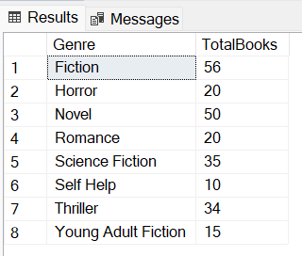

### 5.2.7 Question 2 (b) (vii)

*Input:*

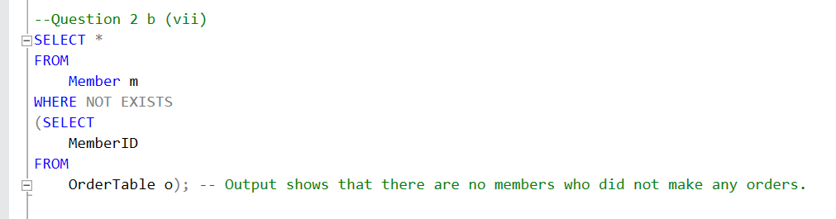

*Output:*

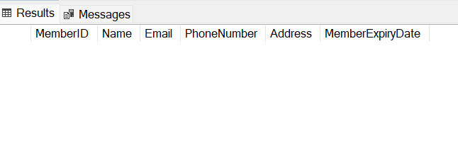

### 5.2.8 Question 2 (b) (viii)

*Input:*

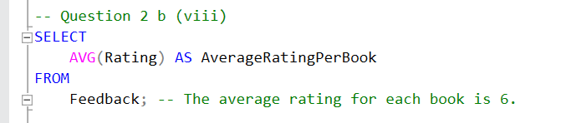

*Output:*

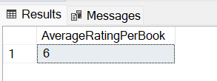

### 5.2.9 Question 2 (b) (ix)

*Input:*

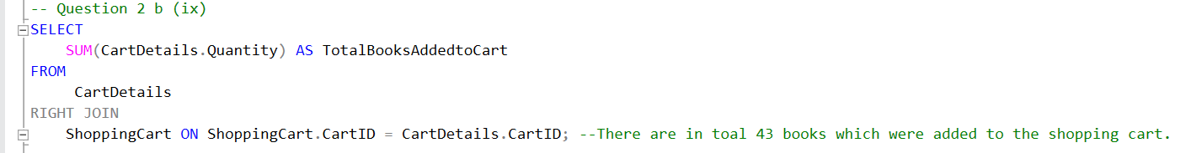

*Output:*

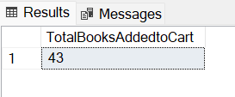

### 5.2.10 Question 2 (b) (x)

*Input:*

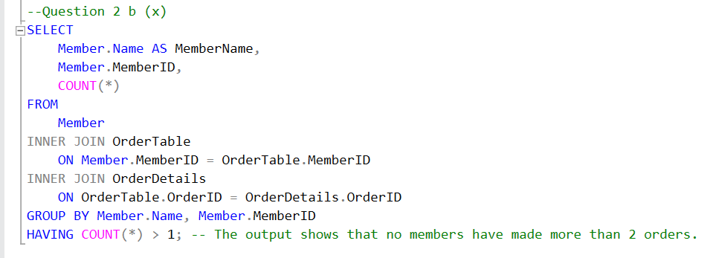

*Output:*

